From:
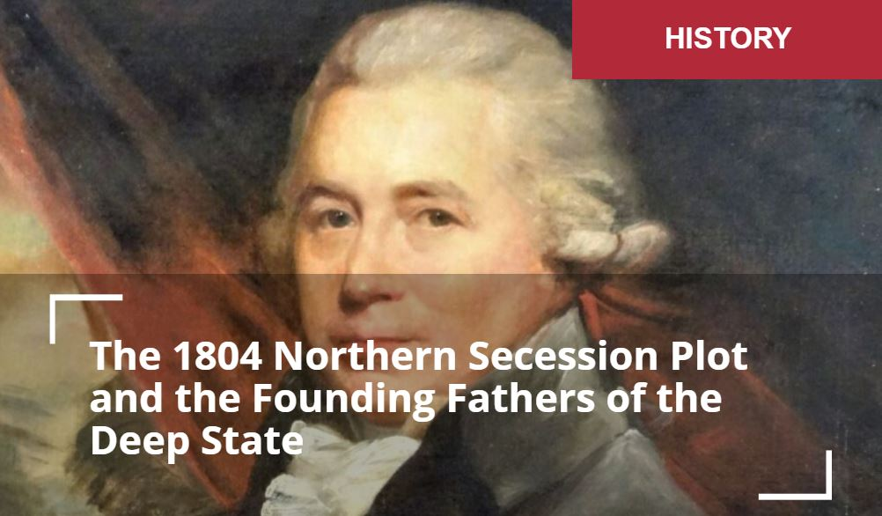
The 1804 Northern Secession Plot and the Founding Fathers of the Deep State
Matthew Ehret

October 6, 2020

“In a choice of Evils let them take the least – Jefferson is in every view less dangerous than Burr.”
– Alexander Hamilton (1800)
The miracle of America’s surviving its many near death experiences over the years can be attributed less to fate and more to the immense sacrifices by great statesmen over the years… one of whom we will explore in this essay.
With America being set on fire by a diverse array of catalysts: hyperinflationary economic blowout, threats of martial law and British-run Deep State adding to the ongoing anarchy sweeping the nation funded by billionaire color revolutionaries, it is easy to become a bit lost, confused and cynical over the future of the republic or even humanity more broadly.
However, when reviewing the history of the USA from its earliest years throughout its numerous moments of near-collapse witnessed in 1804, 1812, 1861-65 to the present, the very fact that the republic even exists at all is nothing less than a miracle which should not be taken for granted. The miracle of America’s surviving its many near death experiences over the years can be attributed less to fate and more to the immense sacrifices by great (and often assassinated) statesmen over the years… one of whom we will explore in this essay.
Hamilton vs. Burr
As I mentioned in my recent paper on Alexander Hamilton’s Genius, America’s first U.S. Treasury Secretary killed by Aaron Burr (aka: the father of Wall Street) in 1804, was indispensable in the young nation’s survival during the first 30 years after 1776. Even though it hasn’t been taught in any western university in generations, Hamilton’s system of political economy which arose from his four reports of 1791 was premised on the practices of
- national banking,
- productive credit generation for long term internal improvements,
- industrial growth (vs slave-based production) and
- protective tariffs.
Most importantly, this system set “economic value” not upon
- the worship of money but rather on
- the creative mental activity of citizens through constant scientific and technological progress.
Between 1776 until his death in 1804, Hamilton used every ounce of his influence to ensure that the many traitorous movements launched by diverse branches of British operations in America (including from his own Federalist Party), and often under the leadership of arch-traitor Aaron Burr, failed to achieve their goals. These operations which included
- Canadian United Empire Loyalists,
- New York financiers and
- southern slave interests,
can collectively be defined as the “founding fathers of today’s deep state” which evolved over the years and took over much of the nation after the death of Franklin Roosevelt.
One of Hamilton’s most important victories during this precarious time occurred during the 1800 presidential elections which still confuses some scholars today. These scholars cannot understand why Hamilton’s feud with Jefferson didn’t stop the former from devoting all of his energy into helping the latter gain the victory over presidential hopeful Aaron Burr. Speaking of his motives for this paradoxical maneuver, Hamilton famously said:
“Mr. Jefferson, though too revolutionary in his notions, is yet a lover of liberty and will be desirous of something like orderly Government – Mr. Burr loves nothing but himself – thinks of nothing but his own aggrandizement – and will be content with nothing short of permanent power in his own hands.”
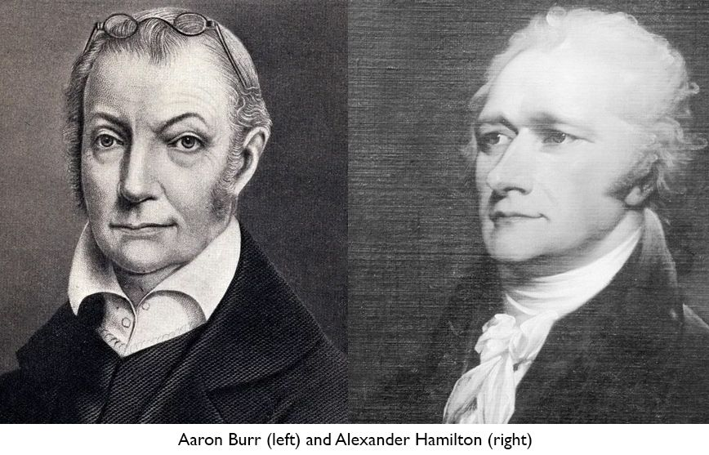
To understand the conditions shaping this strategic fight only 11 years after Ben Franklin died, one must understand how the British Empire used an evil cancer embedded in the young nation to destroy it from within when it became obvious that external force could not succeed.
Slavery: America’s Achilles Heel
Despite the fact that slavery was nearly extinguished by 1792 (1), forces loyal to the British Empire within the “eastern establishment” led by aristocratically minded traitors like Timothy Pickering, Aaron Burr, Col. James Wilkinson, George Cabot and Albert Gallatin worked hard to advance a plot for breaking up the republic into two separate confederacies under the guise that “slave states and free states could not co-exist”. While this fact may have been true, rather than continue the struggle to abolish slavery by imposing the authority of the Constitution, such traitors made the argument that it were best to dissolve the nation and constitution completely. Under these designs, British Canada would merge with northern “free states” under a new Anglo-Saxon confederation, while the slave power would be free to create its own southern confederation. Under this design, both northern and southern confederacies would be defined by a special relationship with England and dominated by the City of London’s economic web of finance.
After Burr’s defeat to Jefferson in 1800 (becoming a distrusted lame-duck vice president), the direct Federal support required for a dissolution of the union was no longer attainable, and so a new plot was hatched that came to life in 1803 which required Burr’s control of New York state.
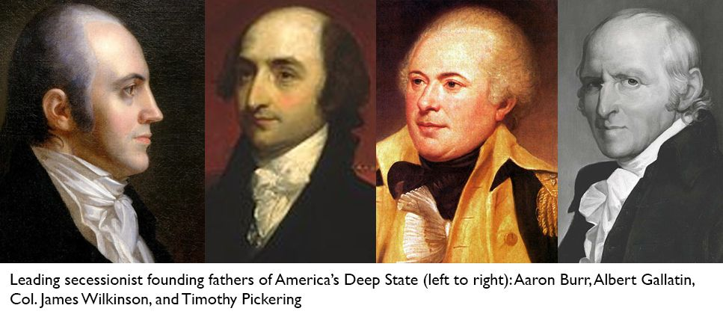
The New England Secessionist Plot
Describing this plot to his co-conspiratorial senator Richard Peters on December 24, 1803, Timothy Pickering (former Secretary of State under President Adams and guiding hand behind the cabal known as the Essex Junto) wrote:
“Although the end of all our Revolutionary labors and expectations is disappointment, and our fond hopes of republican happiness are vanity… I will not yet despair: I will rather anticipate a new confederacy, exempt from the corrupt and corrupting influence and oppression of the aristocratic Democrats of the South. There will be – and our children at farthest will see it – a separation. The white and black population will mark the boundary. The British Provinces, even with the assent of Britain, will become members of the Northern confederacy …”
The strategy described above hinged on bringing New York into the northern secession plot as the economic powerhouse needed to fuse the other “free states” into British Canada.
Proof of Aaron Burr’s Treachery
While many popular historians adamantly choose to deny this fact (some going even so far as to celebrate the life of Burr as a hero), surviving letters have irrefutably proven beyond a shadow of a doubt that Aaron Burr was the unquestioned leader of this plot- as demonstrated by a journal entry written by Essex Junto leader Senator William Plumer who described a conspiratorial meeting at his house involving Senator James Hillhouse, Burr, and Senator Uriah Tracy in the winter of 1803-04. During this meeting, Plumer wrote that Hillhouse “unequivocally declared that it was his opinion that the United States would soon form two distinct governments’; and ‘Burr conversed very freely on the subject … and the impression made on his mind was, that Burr not only thought a separation would not only take place but that it was necessary.”
Writing to Opium-pushing Junto leader George Cabot, Timothy Pickering stated:
“We suppose the British Provinces in Canada and Nova Scotia, at no remote period, perhaps without delay, and with the assent of Great Britain, may become members of the Northern League. Certainly, that government can feel only disgust at our present rulers. She will be pleased to see them crestfallen. She will not regret the proposed division of empire. If with her own consent she relinquishes her provinces, she will be rid of the charge of maintaining them; while she will derive from them, as she does from us, all the commercial returns which her merchants now receive. A liberal treaty of amity and commerce will form a bond of union between Great Britain and the Northern confederacy highly useful to both …”
In another letter of March 4, 1804, Pickering wrote of Burr’s leading role in the plan:
“The Federalists here in general anxiously desire the election of Mr. Burr to the chair of New York; for they despair of a present ascendancy of the Federal party. Mr. Burr alone, we think, can break your Democratic phalanx; and we anticipate much good from his success. Were New York detached (as under his administration it would be) from the Virginia influence, the whole Union would be benefited. Jefferson would then be forced to observe some caution and forbearance in his measures. And, if a separation should be deemed proper, the five New England States, New York, and New Jersey would naturally be united. Among those seven states, there is a sufficient congeniality of character to authorize the expectation of practicable harmony and a permanent union, New York the centre.”
The Plan is Modified
As Pickering alluded to in his letter, this plan hinged upon Burr’s 1804 victory as Governor of New York State and once again, just as in the presidential fight of 1800, Alexander Hamilton devoted all of his energy to ensuring Burr’s defeat resulting in 28,000 votes going to Burr and 35,000 going to his opponent Morgan Lewis.
Without New York on board, the plot for Northern secession could not succeed, and again a new strategy had to be concocted.
Without going into details, it is enough to say that an enraged Burr had decided that Hamilton had to be eliminated once and for all, and in the wake of his gubernatorial defeat, Burr put all of his chips into organizing a duel with his nemesis, resulting in Hamilton’s death on July 12, 1804. (2)
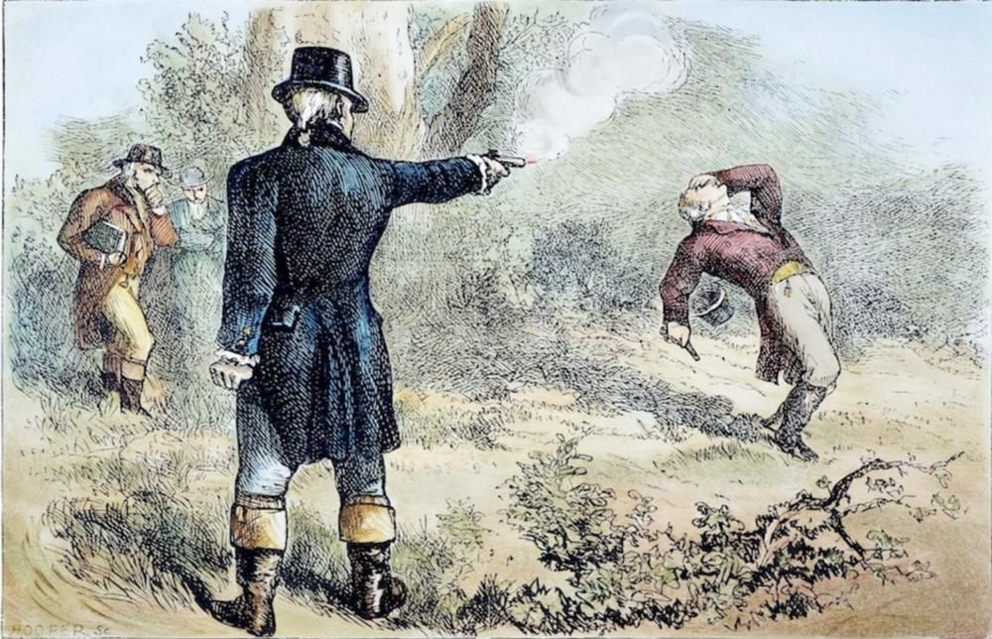
Three weeks after this tragic affair, the British Ambassador Anthony Merry (after meeting with the arch-traitor and Burr confidante Colonel Wilkinson) wrote giddily to the British Foreign Secretary explaining his having recruited Burr to the Empire’s cause of creating a new western Confederacy established by a joint U.S.-British war on Mexico with Burr as it’s head. Ambassador Merry wrote:
“I have just received an offer from Mr. Burr, the actual vice president of the United States (which situation he is about to resign) to lend his assistance to His Majesty’s Government in any manner in which they may think fit to employ him, particularly in endeavouring to effect a separation of the western part of the United States from that which lies between the Atlantic and the mountains, in its whole extant. – His propositions on this and other subjects will be fully detailed to your Lordship by Col. Williamson who has been the bearer of them to me, and who will embark for England in a few days. – It is therefore only necessary for me to add that if, after what is generally known of the profligacy of Mr. Burr’s character, His Majesty’s Ministers should think proper to listen to his offer, his present situation in this country where he is now cast off as much by the democratic as by the federal party, and where he still preserves connections with some people of influence, added to his great ambition and spirit of revenge against the present administration, may possibly induce him to exert the talents and activity which he possesses with fidelity to his employers.”
The Plan Modified… Again
It took two more years for Burr’s true colors to come fully to light when in 1807, Burr was discovered to be at the center of the plot outlined by Ambassador Merry. Instead of relying on “free new England” uniting with Canada, this new plan centered on Burr’s dominance of the newly acquired Louisiana Territory sold by Napoleon to America in 1804 as the basis for a new western confederacy.
Napoleon’s desire to sell this gigantic territory to the Americans was a surprise to all (including the Americans) and threw a big wrench in British plans to take control of this land and again suffocate the USA as a closed system locked onto the Atlantic Coast as had been attempted with the 1774 Quebec Act earlier.
4
By this time, Burr managed to get President Jefferson to approve putting his co-conspirators into powerful positions of the new Louisiana Territory with Col. Wilkinson appointed Governor.
This new plan involved British soldiers working alongside American mercenaries under Burr’s employ who would first take full control of Louisiana, New Orleans, expand the territory by declaring war on Spain. According to testimonies delivered at Burr’s trial, Burr would then turn his attention to the capital where the sitting president would be deposed, and Burr established as Monarch of a new British American confederation. The British had been caught providing boats and money to the mercenaries (40 British boats and 75 mercenaries were apprehended), correspondences were intercepted and soon Burr was standing in front of the supreme court facing treason charges. The diplomat William Eaton testified that Burr told him that “he would turn Congress neck and heels out of doors, assassinate the President, (or what amounted to that,) and declare himself the protector of an energetic Government.”
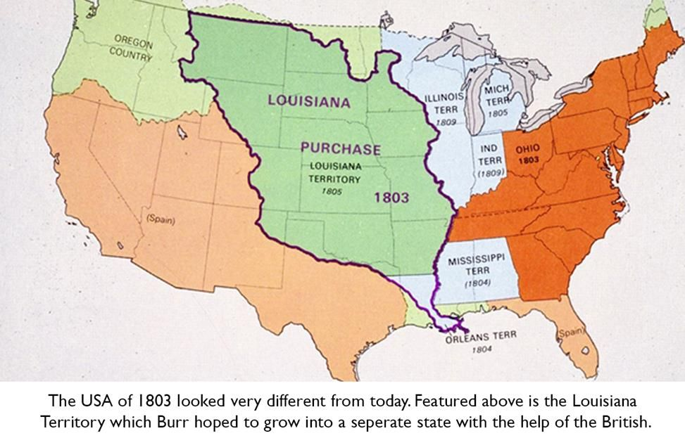
Unfortunately, these testimonies somehow did not qualify as the sort of hard evidence needed to convict Burr (and Ambassador Merry’s smoking gun letter was only discovered decades later) resulting in Burr’s unfortunate acquittal.
Popular rage towards the former Vice President made life impossible within the republic and using a $40,000 “gift” from John Jacob Astor, Burr soon made his way in disguise to Canada where his nephew George Prevost was serving as Governor General. Prevost gave Burr letters of introduction to Lord Castlereagh as he embarked on a ship from Nova Scotia to London where Burr stayed at Jeremy Bentham’s mansion for the next 5 years and, in between heavy doses of opium and prostitutes, plotted with the highest echelons of British intelligence a new scheme for the dissolution of the Union (Bentham was the head of British Intelligence Services in those days and extended networks across the globe).
While in London, Burr wrote of Bentham (the pervert who wrote such immoral tracts as In Defense of Usury and In Defense of Pederasty): “He is, indeed, the most perfect model that I have seen or imagined of moral and intellectual excellence. He is the most intimate friend I have in this country, and my constant associate. I live in his house and compose a part of his family.”
Burr Returns Home and a New Plot is Hatched
Finally returning to the United States in the months before the War of 1812, Burr began rebuilding his political machine with a new focus on the use of the Wall Street dominated Democratic Party of Andrew Jackson and Martin Van Buren which would ultimately drive America into a Civil War five decades later.
In 1815, Burr laid out the earliest plan for raising the racist puppet Andrew Jackson to the status of President of the USA in a letter to Joseph Alston (Burr’s son-in-law and former Governor of South Carolina) saying:
“If, then, there be a man in the United States of firmness and decision, and having standing enough to afford even a hope of success, it is your duty to hold him up to public view: that man is Andrew Jackson. Nothing is wanting but a respectable nomination, made before the proclamation of the Virginia caucus, and Jackson’s success is inevitable. If this project should accord with your views, I could wish to see you prominent in the execution of it. It must be known to be your work.”
Though it took another decade, the eventual federal takeover of the Burr machine under the combined presidencies of Andrew Jackson and Martin van Buren (ruling from 1828-1840) represented a massive defeat of the Hamiltonian networks then led by John Quincy Adams, William Harrison, Matthew Carey and Henry Clay. The only two successes of the Hamiltonian nationalists then centered in the Whig party to regain control during the 1840-1860 period found Whig presidents dying under mysterious circumstances before they could extract the British rot (Harrison in 1840 and Taylor in 1852).
Under Jackson and Van Buren, protectionism was dismantled in favor of British free trade, speculation grew rampantly as did the southern slave power as the south was cleansed of Cherokee under the Trail of Tears and given over to racist oligarchs. The National Bank was destroyed in Jackson’s last year in office, cutting the USA off from its only means of generating sovereign credit for development resulting in the panic and depression of 1837. All major infrastructure projects were cancelled under the banner of “paying the debt” and America’s path to dissolution dreamed of by Burr and his Deep State cohorts in 1804 was accelerated in short order. This story is documented thoroughly in Michael Kirsch’s ground breaking 2012 article How Andrew Jackson Destroyed the United States.
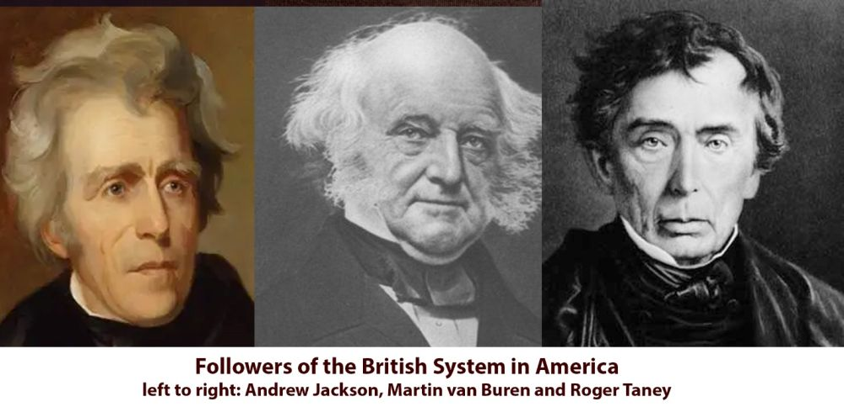
The role of British operations both within America itself as well as British Canada cannot be overstated when evaluating the short and precarious experience of the United States from 1776 to the present. Were America is to survive the coming maelstroms, then it is safe to say that ignorance of this continuous intention to undo the revolution of 1776 can[not] any longer be tolerated.
In the next installment, I will demonstrate how British Canada was used during the bloody 1861-1865 Civil War to destroy Lincoln’s efforts to save the beleaguered union from the [Canadian, presumably] North while simultaneously fighting to stop the British-funded secessionist movements from the South. During this exercise, don’t be surprised to discover that
- Lincoln’s murder was deployed from the Confederate Secret Services stronghold of Montreal, or that
- Canada’s modern origins as an 1867 “northern confederacy” were shaped purely by a geopolitical desire to break the republic during the 19th and 20th centuries.
Lastly… keep in mind that these historical lessons are not about the past, but rather are about our future.
The author can be reached at matt.ehret@tutamail.com
(1) Every single state of the union had shut down the slave trade by 1792, with six states completely outlawing all slavery and seven banning all imports of slavery with serious programs designed to emancipate slaves over the coming years as industrial growth was hoped to replace cash cropping agrarian systems.
The views of individual contributors do not necessarily represent those of the Strategic Culture Foundation.
Tags:
Alexander HamiltonCivil WarHistoryUnited States

